Integration of VL53L3CX breakout board on 96board dragon board 410C

Hardware adaptation
We use an AISTAR MIPI Adapter between Ewok+ VL53L3CX satellite and the board 410C
https://github.com/Kevin-WSCU/96Boards-Camera/tree/master/AISTARVISION%20MIPI%20Adapter%20V2.1

The VL53L3CX satellite connected to the adapter board on top of a dragon board 410c
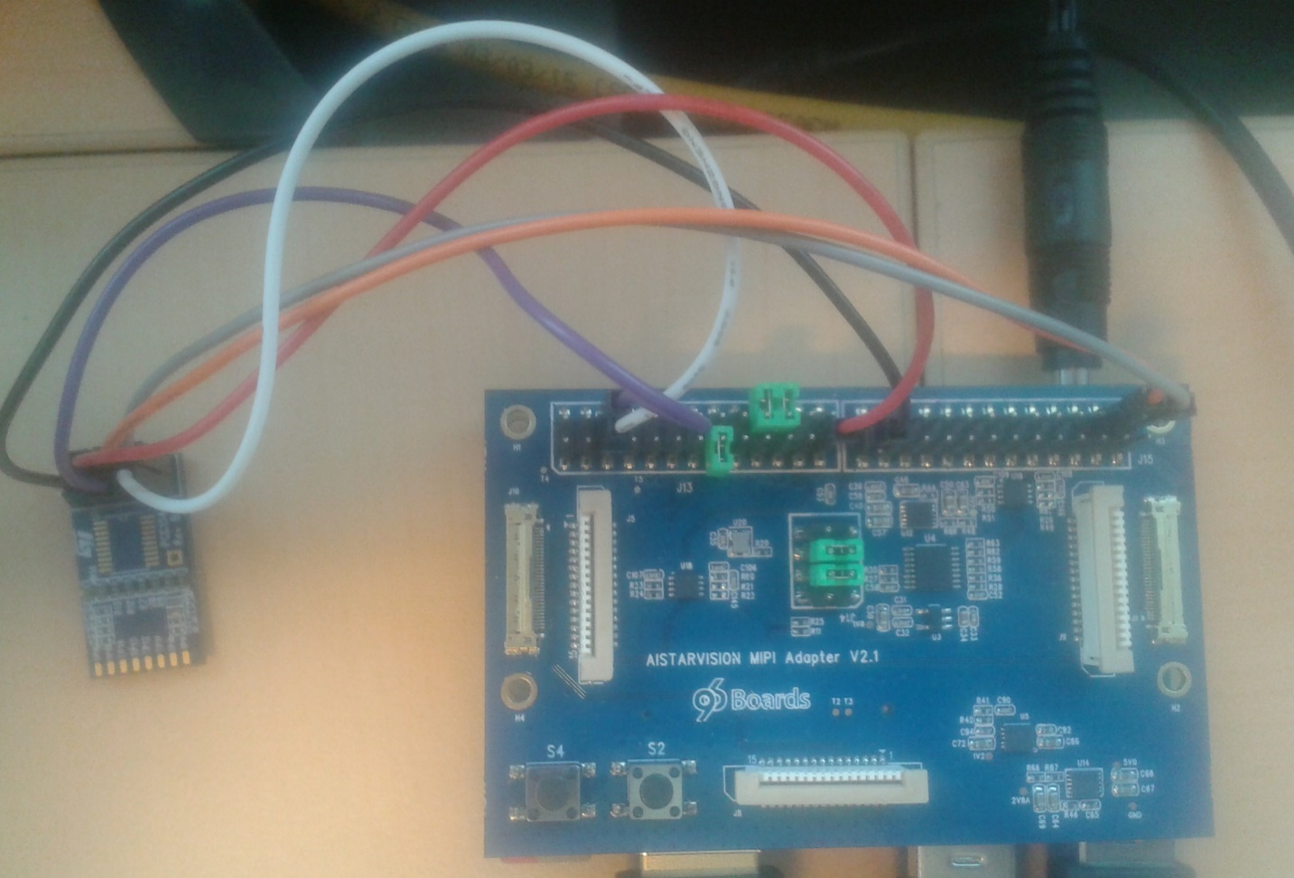

VL53L3CX exposes I2C, Xshutdown and Interrupt pins which must be connected to respective I2C and GPIOs on board 410C through the AISTAR MIPI Adapter.

Adapter J13 & J15 connectors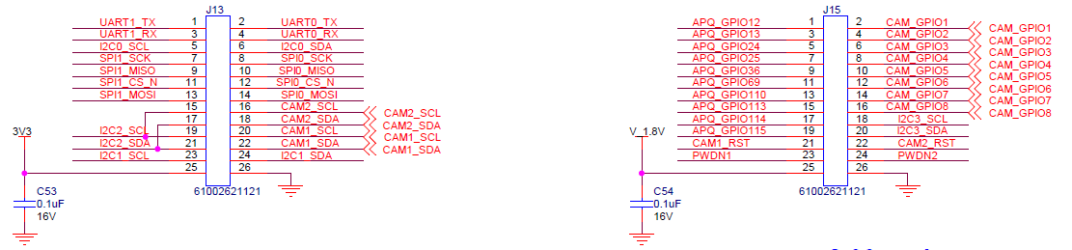
VL53L3CX Satellite
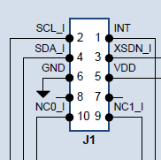
- Connect VL53L3CX pins 2-4 to I2C0 located on pins 5-6 connector J13 on the adapter
- Connect Int (VL53L3CX J1 pin 1) to Gpio 12 pin 1 connector J15 on the adapter
- Connect Xsdn (VL53L3CX J1 pin 3) to Gpio 13 pin 3 connector J15 on the adapter
- 3V3 applied on VL53L3CX J1 pin 5 is taken from pin 25 connector J13 on the adapter
- GND VL53L3CX J1 pin 6 is fitted on pin 26 connector J15 on the adapter

Software requirements
Linux driver version l3cx_release_1.0.3 has been used on Linaro based linux version 4.14.15-st
Source code on SVN : http://codex.cro.st.com/svnroot/ewokp25/LinuxDriver/tags/l3cx_release_1.0.3/

Instruction for build kernel+daemon and run basic tests through phio user application

Driver build
export KDIR/home/linaro/linux-headers
export DRIVER_DIR=<location where you put the package of the linux driver>
export DRIVER_DIR=${DRIVER_DIR}/driver/vl53Lx/
cd $DRIVER_DIR
make clean
make

Driver installation
sudo insmod stmvl53lx.ko force_device=1 adapter_nb=0 xsdn_gpio_nb=13 intr_gpio_nb=12
sudo chmod 777 /dev/stmvl53lx_ranging

Daemon build & launch
cd $DRIVER_DIR/../../android/hardware/vl53lx_daemon/
sudo make CC=gcc clean all test
./vl53lx_daemon_main &

User space test application build
cd $DRIVER_DIR/../../android/hardware/vl53lx_test/
make CC=gcc clean all

Launching user space test application
Existing options can be displayed thanks to --help option
./phio --help

Launch 10 ranging measurements
./phio -s -Z=10 -S

Instruction for build full kernel driver and run basic tests through phio user application

Driver build
export KDIR=/home/linaro/linux-headers
export DRIVER_DIR=<location where you put the package of the linux driver>
export DRIVER_DIR=${DRIVER_DIR}/driver/vl53Lx/
cd $DRIVER_DIR
make clean
make VL53LX_FULL_KERNEL=1

Driver installation
sudo insmod stmvl53lx.ko force_device=1 adapter_nb=0 xsdn_gpio_nb=13 intr_gpio_nb=12
sudo chmod 777 /dev/stmvl53lx_ranging

User space test application build
cd $DRIVER_DIR/../../android/hardware/vl53lx_test/
make CC=gcc clean all

Launching user space test application
Existing options can be displayed thanks to --help option
./phio --help

Launch 10 ranging measurements
./phio -s -Z=10 -S

